**Solution Architecture**

|  |  |
| --- | --- |
| **Date** | 19 September 2022 |
| **Team ID** | PNT2022TMID40750 |
| **Project Name** | Inventory Management System for Retailers |
| **Maximum Marks** | 4 Marks |

**Solution Architecture:**

Solution architecture is a complex process – with many sub-processes – that bridges the gap between business problems and technology solutions. Its goals are to:

* Find the best tech solution to solve existing business problems.
* Describe the structure, characteristics, behavior, and other aspects of the software to project stakeholders.
* Define features, development phases, and solution requirements.
* Provide specifications according to which the solution is defined, managed, and delivered.

**Example - Solution Architecture Diagram: *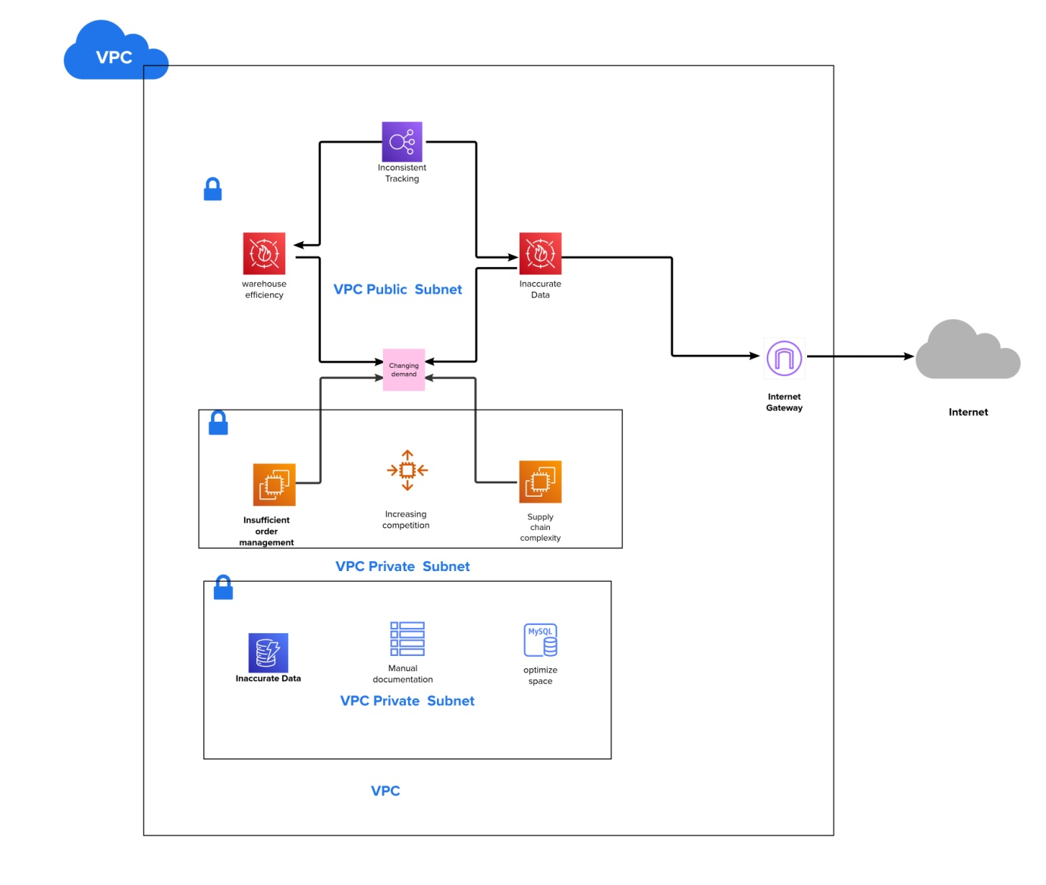***

Figure 1: Architecture and data flow of the voice patient diary sample application

**Reference:**

<https://app.mural.co/t/inventorymanagementsystem0923/m/inventorymanagementsystem0923/1664949289401/f06301abdbcca5e1f3940d03bbdcd01f086dce72?sender=uf7f11e5be2266fe545f93649>